

Student Name……………………………………

FURTHER MATHEMATICS

TRIAL EXAMINATION 1

2012

Reading Time: 15 minutes
Writing time: 1 hour 30 minutes

Instructions to students
This exam consists of Section A and Section B.
Section A contains 13 multiple-choice questions from the core, 'Data Analysis'.
Section A is compulsory and is worth 13 marks.
Section B consists of 6 modules each containing 9 multiple-choice questions. You should choose 3 of these modules and answer every question in each of your chosen modules.
Each of the modules is worth 9 marks.
Section B begins on page 9 of this exam.
There is a total of 40 marks available for this exam.
Unless otherwise stated the diagrams in this exam are not drawn to scale.
Students may bring one bound reference into the exam.
An approved graphics or CAS calculator may be used in the exam.
An answer sheet appears on page 36 of this exam.
Formula sheets can be found on pages 34 and 35 of this exam.

This paper has been prepared independently of the Victorian Curriculum and Assessment Authority to provide additional exam preparation for students. Although references have been reproduced with permission of the Victorian Curriculum and Assessment Authority, the publication is in no way connected with or endorsed by the Victorian Curriculum and Assessment Authority.

© THE HEFFERNAN GROUP 2012
This Trial Exam is licensed on a non transferable basis to the purchasing school. It may be copied by the school which has purchased it. This license does not permit distribution or copying of this Trial Exam by any other party.

SECTION A

CORE: Data analysis

This section is compulsory.

The following information should be used to answer questions 1, 2 and 3.

The ordered stemplot below shows the results of a maths test, marked out of 30, for 19 students.

Test results
0 | 8
1 | 2
1 | 5
2 | 1 | 2 | 3 | 4
2 | 5 | 5 | 6 | 6 | 7 | 8
3 | 0 | 0 | 0 | 0 | 0 | 0

Question 1

The shape of this distribution is best described as

- negatively distributed
- negatively skewed
- positively skewed
- positively skewed with outliers
- approximately symmetric.

Question 2

For these 19 students, the interquartile range (IQR) of their maths test results is

- 6
- 7
- 8
- 14
- 26

Question 3

The mean and standard deviation of this distribution, correct to one decimal place, are given respectively by

- 6.4 and 12.8
- 12.8 and 6.4
- 12.8 and 12.1
- 24.3 and 6.4
- 24.3 and 12.1

The following information should be used to answer questions 4 and 5.

The weight of an avocado in a large crop is approximately normally distributed with a mean of 255g and a standard deviation of 11g.

Question 4

The probability that a randomly selected avocado weights between 255g and 288g is

- 45%
- 47%
- 48.5%
- 49.7%
- 49.85%

Question 5

An avocado with a standardized weight of 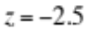 would have an actual weight of

- 227.5g
- 238.5g
- 244g
- 252.5g
- 282.5g

The information below relates to questions 6 and 7.

The average daily sleeping time (in hours) and age (years) were recorded for 9 children and are shown in the scatterplot below.
A least squares regression line was fitted to the data and is shown below.
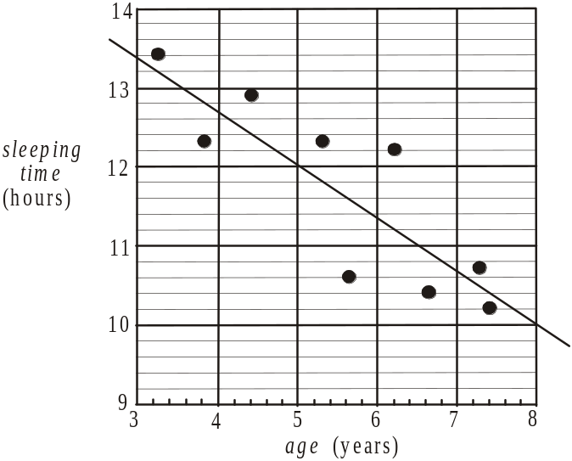

Question 6

A possible plot of the residuals against age is closest to
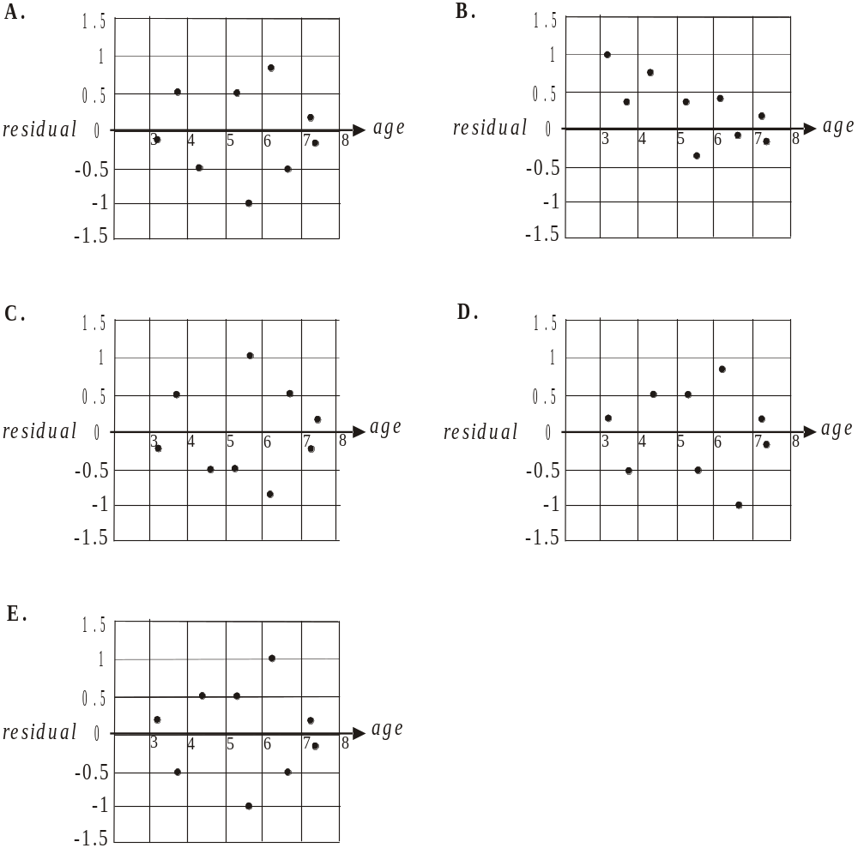

Question 7

By inspection, the value of r, the product-moment correlation coefficient for this data, is closest to

- – 0.90
- – 0.58
- – 0.14
- 0.68
- 0.93

Question 8

In a study involving university students, the correlation between the number of late night hours spent studying and concentration levels was found to be 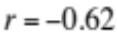.
It can be concluded from this information that

- less late night hours spent studying causes better concentration levels.
- 62% of students who study late at night have higher concentration levels.
- 62% of students who study late at night have lower concentration levels.
- there is some association between increased late night hours spent studying and decreased concentration levels.
- 62% of students don’t study late at night.
Question 9

The data shown in the table is represented on a scatterplot given below.

x | y
1 | 2
2 | 3
3 | 5
4 | 6
5 | 7
6 | 11
7 | 39
8 | 47

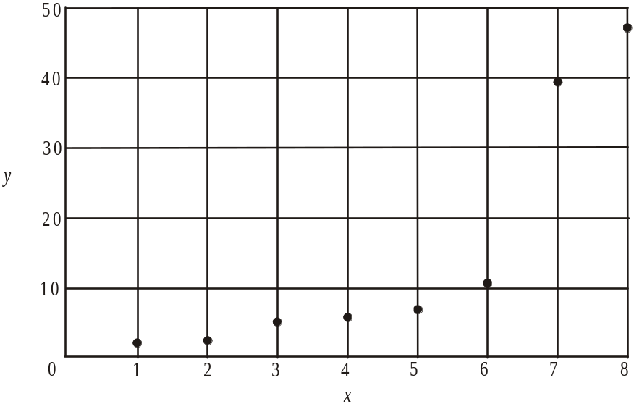

In order to linearise the scatterplot, a reciprocal transformation is applied to the y axis.
With x as the independent variable, the equation of the least squares regression line of the transformed data is closest to

- 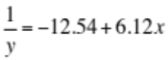
- 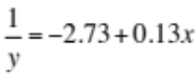
- 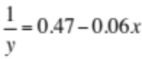
- 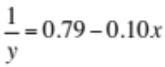
- 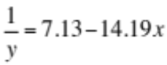
Question 10

The time series plot below shows monthly retail sales figures between 2009 – 2011 for a retail business.

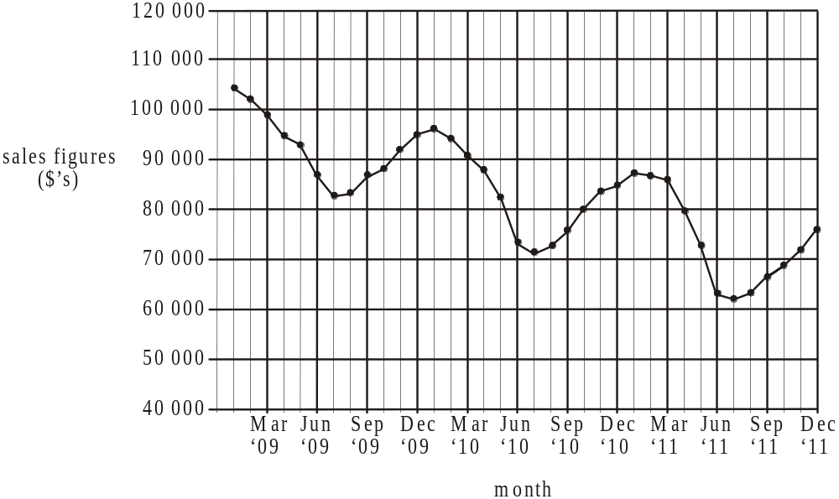

The time series plot is best described as showing

- cyclic variation
- cyclic variation with a decreasing trend
- seasonal variation
- seasonal variation with a decreasing trend
- a decreasing trend.

Question 11

The table below shows the car sales at a dealership between 1999 and 2008.

Year | 1999 | 2000 | 2001 | 2002 | 2003 | 2004 | 2005 | 2006 | 2007 | 2008
Number | 431 | 462 | 445 | 475 | 452 | 489 | 431 | 492 | 512 | 473

In order to smooth the time series a four-point moving mean with centring is used.
The smoothed value for the number of cars sold in 2005 is

- 245.25
- 466
- 473.5
- 475.2
- 481

Question 12

The retail fashion sales for a large department store during Spring has a seasonal index of 1.25. To allow for the effects of seasonality, these retail fashion sales for Spring should be

- increased by 20%
- increased by 25%
- increased by 75%
- decreased by 20%
- decreased by 25%

Question 13

The time series plot below shows the decline in the quantity of fish (in tonnes) caught by a fisherman from 1995 – 2004 inclusive.

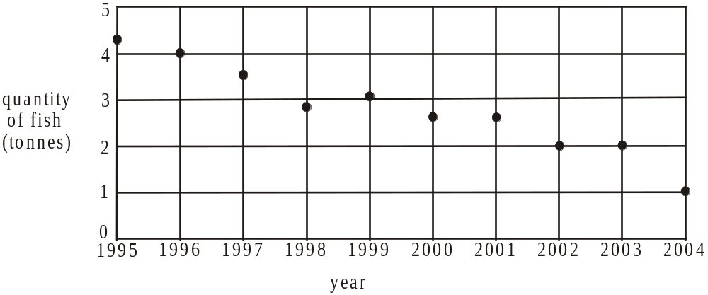

A three median line is fitted to the data. It shows that on average, the decrease in tonnes in the quantity of fish caught per year was closest to

- 0.21
- 0.29
- 0.35
- 0.39
- 0.44

SECTION B

Module 1: Number patterns

If you choose this module all questions must be answered.

Question 1

For the geometric sequence 2.5, 1, 0.4,… the common ratio is

- 0.4
- 0.6
- 1.5
- 2.5
- 6.25

Question 2

The first six terms of a Fibonacci related sequence are 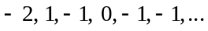
The next term in the sequence is

- – 2
- – 1
- 0
- 1
- 2

Question 3

The first three terms of an arithmetic sequence are 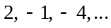
The nth term of this sequence, , is given by

- 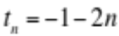
- 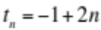
- 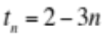
- 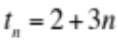
- 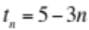

Question 4

For the difference equation with the rule 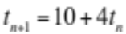, the third term is equal to 18. The value of the first term is

- – 4
- – 2
- 2
- 4
- 8
Question 5

The amount of a certain drug given daily to a horse by a vet forms a geometric sequence with a common ratio of 1.1. If on day one the vet gives the horse 4mg of the drug, the amount in mg, given on day 25 will be closest to

- 9.8
- 10.8
- 30.4
- 39.4
- 43.3

Question 6

The first six terms of a sequence are plotted on the graph below.
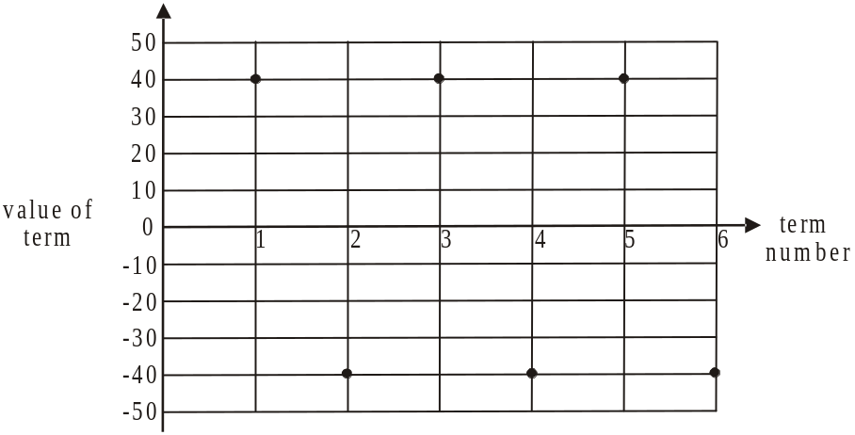

The sequence could be

- arithmetic with 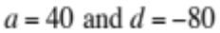
- arithmetic with 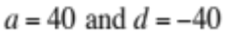
- geometric with 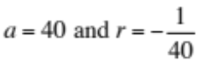
- geometric with 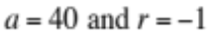
- a Fibonacci related sequence.

Question 7

A farmer plants 160 trees one year, 120 the next year and 90 the next year. If the farmer continued this pattern of planting trees indefinitely then the number of trees planted in all would be

- 213
- 360
- 480
- 493
- 640
Question 8

Norm has a large stamp collection. Each year he donates 30% of his collection to others and purchases 200 stamps to add to his collection. The number of stamps in the collection in the nth year is given by 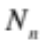.
Norm can calculate the number of stamps he has in his collection from one year to the next using the rule

- 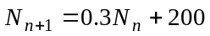
- 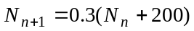
- 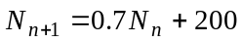
- 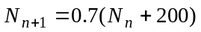
- 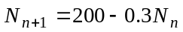

Question 9

Regina knits a footy scarf. She knits 5cm using black wool then 8cm using white wool then 11cm using black wool and then 14cm using white wool. She continues to follow this pattern alternating colours until the scarf is 4.4m long. The length of the last section that she knits is

- black and 50cm long
- black and 52cm long
- black and 58cm long
- white and 50cm long
- white and 52cm long.

Module 2: Geometry and trigonometry

If you choose this module all questions must be answered.

Question 1
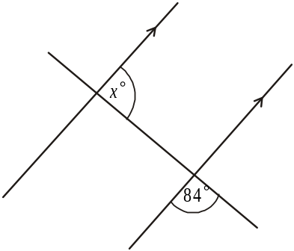

In the diagram above the value of x is

- 84
- 86
- 90
- 96
- 104

Question 2
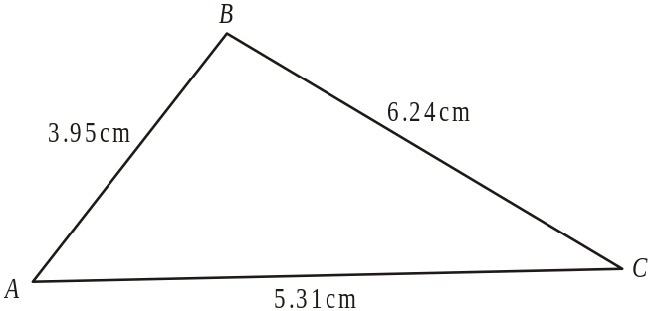

The area, in cm², of the triangle ABC shown above can be found using Heron’s formula

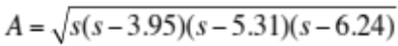

The value of s is

- 3.88
- 5.17
- 7.75
- 15.5
- 31

Question 3

A piece of polished marble in the shape of a square based pyramid sits on a timber base which is in the shape of a square prism as shown below.

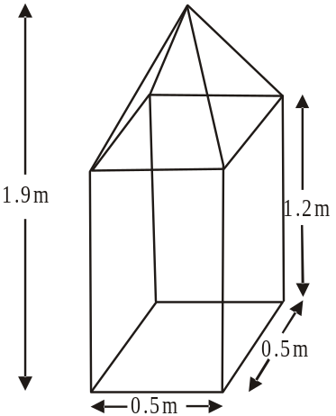

The sidelengths of the marble base and the timber base are 0.5m, the height of the timber base is 1.2m and the height of the whole piece is 1.9m.
The total volume, in 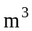, of the marble and the base is closest to

- 0.36
- 0.4
- 0.42
- 0.46
- 0.66

Question 4
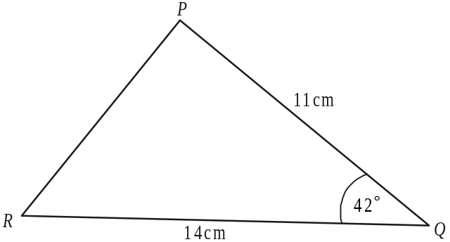

In triangle PQR shown above, 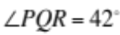. The length of side PQ is 11cm and the length of side QR is 14cm.
The length, in cm, of side PR is closest to

- 7.9
- 8.7
- 9.4
- 14.2
- 17.3

Question 5

Two spheres, X and Y, are shown below.
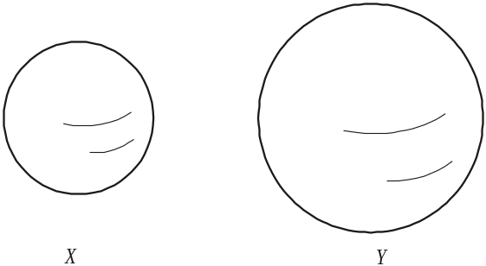

The radius of sphere X is one third the radius of sphere Y. The surface area of sphere Y is 1098cm².
The surface area of sphere X, in cm², is

- 40.6
- 122
- 366
- 3294
- 9882

Question 6

A farmer leaves his farmhouse and drives due east for 3km to his farm gate where he stops. From here he changes direction and drives along a straight track for 8km to reach a shed. After having inspected the shed he drives due north back to his farmhouse. The bearing of the shed from the farm gate is closest to

- 22°
- 68°
- 202°
- 248°
- 249°

Question 7

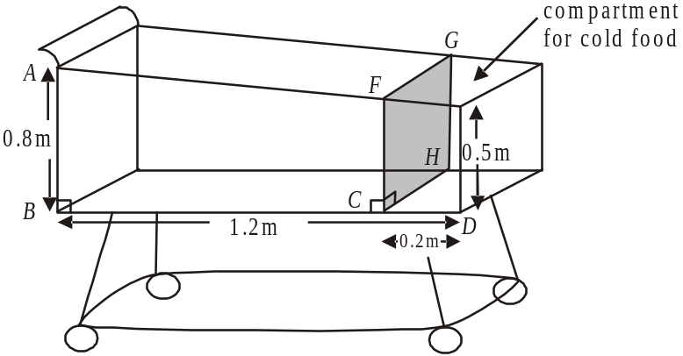

In a supermarket trolley, a rectangular panel (shown in the diagram as CFGH) is inserted to make a compartment for cold foods.
The back of the trolley basket has a height of 0.8m and the front has a height of 0.5m. The length of the trolley is 1.2m and the cold compartment is 0.2m long.
The height, in metres, of the panel, shown as CF, is

- 0.55
- 0.56
- 0.58
- 0.59
- 0.63

Question 8

A timber frame being constructed is in the shape of a triangular prism and is shown in the diagram below.
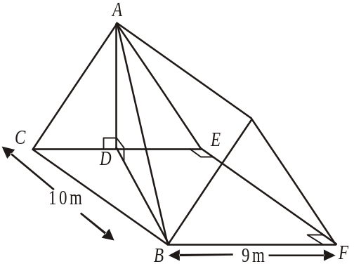

A supporting beam of length 15m extends from point A to point B.
The side length BF is 9m long, the side length BC is 10m long and 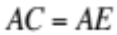.
The height in metres, of the frame, indicated by AD, is

- 10.06
- 10.23
- 12.05
- 18.06
- 18.58

Question 9

In the diagram below, triangle PQR has an area of 15cm², 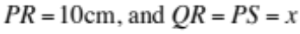cm. Also, angle .

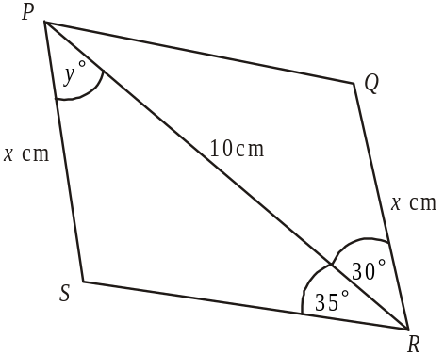

The value of y is closest to

- 65°
- 68°
- 70°
- 72°
- 73°

Module 3: Graphs and relations

If you choose this module all questions must be answered.

Use the information below to answer Questions 1 and 2.

The graph below shows the percentage of saturated oxygen in a fish tank over a 12 week period.

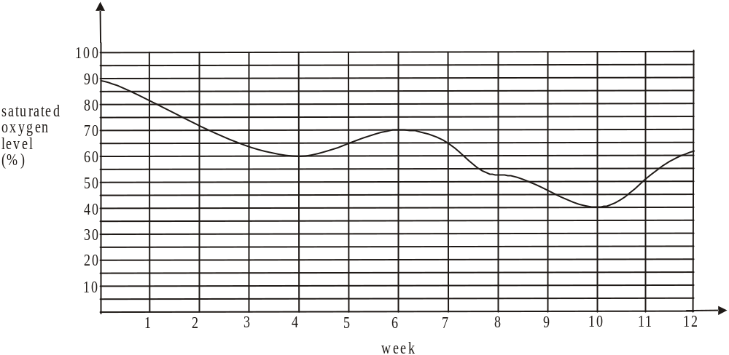

Question 1

Over this 12 week period the saturated oxygen levels were less than 65% for

- exactly 5 weeks
- between 5 and 6 weeks
- exactly 6 weeks
- between 6 and 7 weeks
- approximately 7 weeks

Question 2

The average rate of increase in the saturated oxygen level (in percent/week) in the fish tank between week 4 and week 6 is

- 2
- 2.5
- 5
- 10
- 70
Question 3

A straight line passes through the points 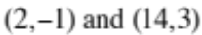. The equation of the line is

- 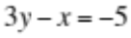
- 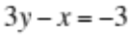
- 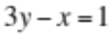
- 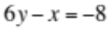
- 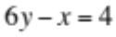

Question 4

Annie has fixed costs of $240 and a cost of $15 for every bag that she produces.
Last weekend Annie made a profit on the sale of her bags by selling

- 10 bags at $38 each
- 15 bags at $30 each
- 20 bags at $26 each
- 25 bags at $25 each
- 30 bags at $20 each

Question 5

Liv works day shifts and night shifts. Let x represent the number of day shifts she works a month and let y represent the number of night shifts she works a month.
Liv earns $200 for a day shift and $320 for a night shift. Liv has to earn at least $4800 a month.
An inequality representing this information is

- 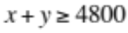
- 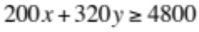
- 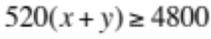
- 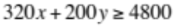
- 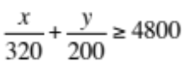

Question 6

The graphs below show the cost (in dollars) of producing n items and the revenue (in dollars) from the sale of n items.

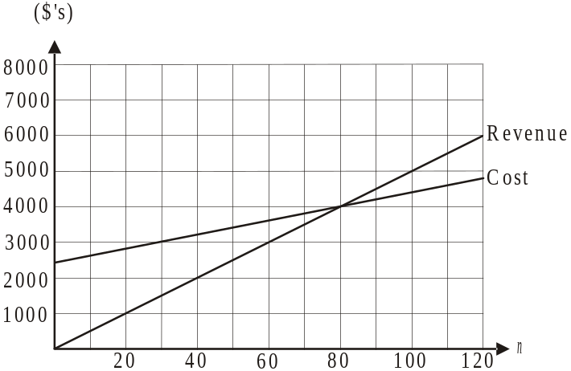

Which one of the following statements is not true?

- Each item is sold for $50.
- Break-even occurs when 80 items are sold.
- The fixed costs are $2400.
- Break-even occurs when revenue equals $3000.
- The cost of producing one item is $20.

Question 7
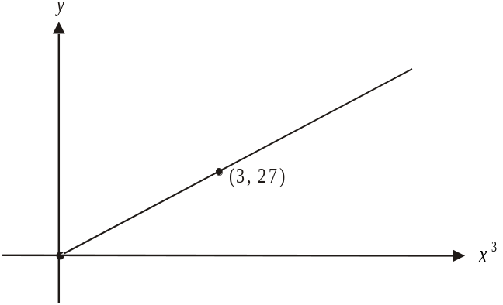

The graph above shows a relationship between y and x³.
The relationship between y and x is given by
- 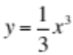
- 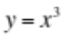
- 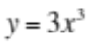
- 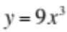
- 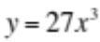

Question 8

The pair of simultaneous linear equations that has no solution is

- 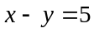
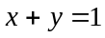

- 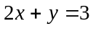
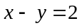

- 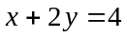
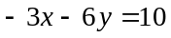

- 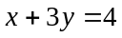
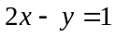

- 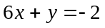
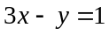

Question 9

The feasible region in a linear programming problem is shaded in the diagram below.

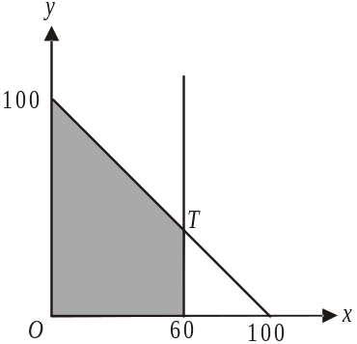

If an objective function P, has its maximum value at point T, then

- 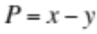
- 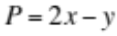
- 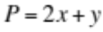
- 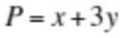
- 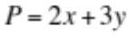

Module 4: Business-related mathematics

If you choose this module all questions must be answered.

Question 1

Kate invested $12 000 at a simple interest rate of 3.8% per annum. She earned a total of
$1 368 in interest.
Kate had the money invested for

- 2 years
- 3 years
- 4 years
- 5 years
- 6 years

Question 2

Pete paid $32 000 for his work truck. It is to be depreciated by 9% of its purchase price per year. After 5 years the value of the truck is

- $14 400
- $16 700
- $17 600
- $19 969
- $21 944

Question 3

The transaction details of a bank account for June 2011 are shown below.

Date | Transaction details | Withdrawal | Deposit | Balance
7 Jun 11 | Withdrawal ATM | $300 |  | 1852.00
12 Jun 11 | Transfer to acc 733 432 4398 | $550 |  | 1302.00
23 Jun 11 | Deposit |  | $150 | 1452.00
29 Jun 11 | Withdrawal | $300 |  | 1152.00

The customer receives simple interest at the rate of 4.1% per annum on the minimum monthly balance for this account.
The interest that the customer will receive for June 2011 is closest to

- $3.94
- $4.45
- $4.96
- $47.23
- $53.38

Question 4

Sue invests an amount of money in an account where the interest rate is 4.4% per annum compounding quarterly. After 5 years Sue’s investment is worth $27 937.10.
The amount Sue invested was

- $22 447
- $23 765
- $26 450
- $26 740
- $27 630

Question 5

A brand new van is depreciated at the rate of 26 cents per kilometre travelled. After having travelled a total distance of 80 000 kilometres it is valued at $13 700. The purchase price of the van was

- $20 800
- $23 600
- $28 400
- $34 500
- $39 700

Question 6

Julie takes out a reducing balance loan of $140 000 which she will completely repay over 6 years. The interest rate is 6.9% per annum.
Julie’s monthly repayments will be

- $2 380.14
- $4 629.13
- $9 739.83
- $12 107.29
- $23 805.16

Question 7

Victoria receives an annual amount from a family bequest. The first payment she received in 1998 was $10 000. That amount increased each year by 5%. The amount she received in 2004 was

A. $10 156.25
B. $12 762.80
C. $13 401.00
D. $14 071.00
E. $113 906.00

Question 8

Rudolph took out a reducing balance loan of $210 000 at an interest rate of 7.1% per annum compounding quarterly. He made quarterly repayments of $6 536.73 in order to pay the loan off in 12 years.
Halfway through the loan, the amount of principal that Rudolph still owed was

- $83 154.80
- $105 000.00
- $126 845.17
- $172 795.52
- $192 378.73

Question 9

Ted invested $65 000 in an annuity at an interest rate of 5.8% per annum compounding half-yearly.
Ted will receive half-yearly payments of $3 273.53 until there are no funds left in the annuity.
Which of the following statements is true?

- The annuity will last for 30 years.
- Ted receives back his initial investment at the end of the annuity.
- Ted receives a total of more than $40 000 in interest over the life of the annuity.
- After 10 years there will be less than $25 000 left in the annuity.
- Ted will receive a total of just under $100 000 in payments over the life of the annuity.
Module 5: Networks and decision mathematics

If you choose this module all questions must be answered.

Question 1
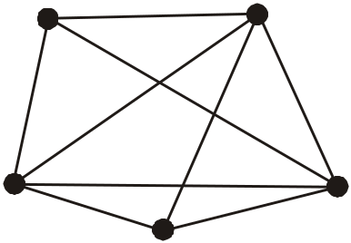

The graph shown above could not be described as

- planar
- simple
- connected
- complete
- undirected

Question 2
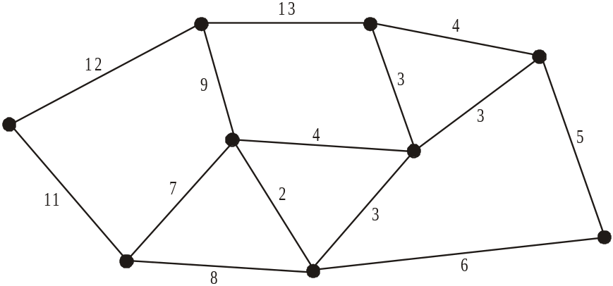

The network shown above has a minimal spanning tree that includes an edge with a weight of

- 6
- 8
- 11
- 12
- 13

Question 3

A connected, planar graph that has 7 vertices could have

- 5 edges and 5 faces
- 7 edges and 5 faces
- 8 edges and 6 faces
- 10 edges and 8 faces
- 12 edges and 7 faces

Question 4

The tasks that four friends are able to undertake are shown on the bipartite graph below.
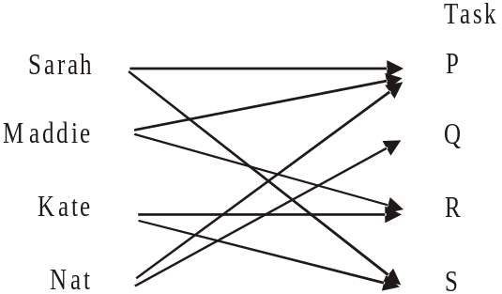

This task allocation can be represented by the matrix.

- 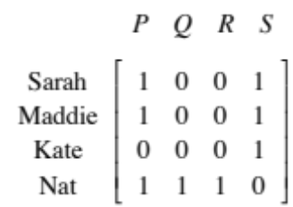
- 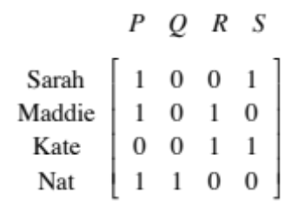
- 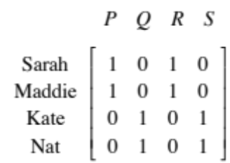
- 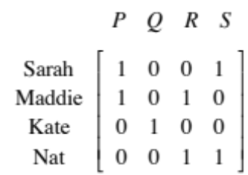
- 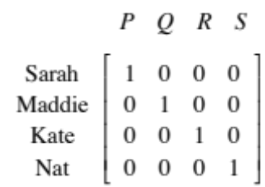

Question 5
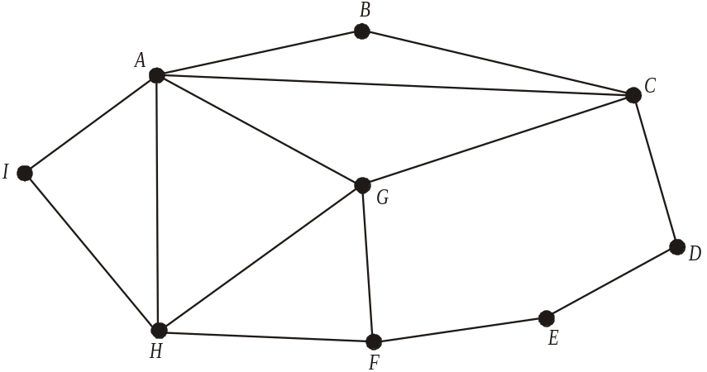

The graph shown above represents the roads forming the route taken by a bus. The bus leaves from vertex A and returns to vertex A, and has travelled along each edge just once. The graph has one edge missing.
That missing edge is between vertices

- A and F
- A and G
- C and H
- F and G
- G and E

Use the following information to answer questions 6, 7 and 8.

The ten activities involved in a project, together with the time in weeks taken to complete them is shown on the network below.

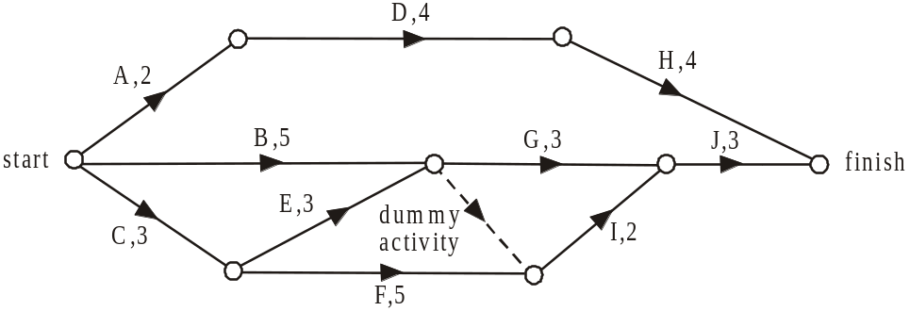

Question 6

The immediate predecessor(s) of activity I is/are

- activity F
- activities C and F
- activities B and F
- activities B, E and F
- activities B, C, E and F

Question 7

The minimum time in weeks, in which this project can be completed is

- 9
- 10
- 11
- 12
- 13

Question 8

Which activity has a float time of 2 weeks?

- activity A
- activity B
- activity C
- activity D
- activity E

Question 9

The time in minutes taken for four technicians to complete four different types of repairs is shown in the table below.
 | Repair 1 | Repair 2 | Repair 3 | Repair 4
Jim | 20 | 30 | 40 | 35
Lee | 10 | 15 | 20 | 10
Stuart | 60 | 50 | 65 | 70
Sam | 40 | 30 | 35 | 45

The tasks are allocated; with one person allocated to each repair, so as to minimise the time taken to complete the four different types of repairs. That total minimum time taken in minutes is

- 55
- 85
- 110
- 115
- 135

Module 6: Matrices

If you choose this module all questions must be answered.

Question 1

The order of the matrix 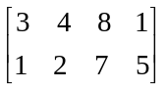 is

- 2
- 4
- 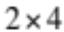
- 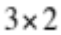
- 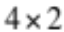

Question 2

The matrix 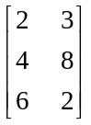 could also be written as

- 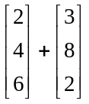

- 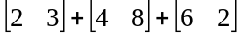

- 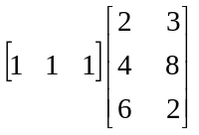

- 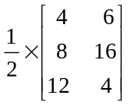

- 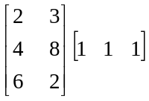

Question 3

The matrix equation below represents a system of simultaneous linear equations.

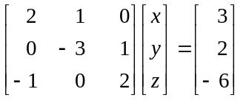

One of these linear equations is

- 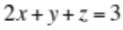
- 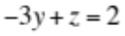
- 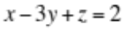
- 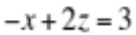
- 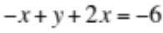

Question 4

The four matrix equations below, each represent a system of simultaneous linear equations.

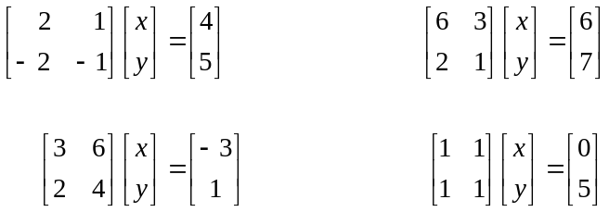

The number of these systems of simultaneous linear equations which have a unique solution is

- 0
- 1
- 2
- 3
- 4

Question 5

The price, in dollars, of three different sized televisions for three different brands at a major retail store is shown in the table below.
Television size | Brand
Television size | A | B | C
40 inch | 800 | 750 | 920
46 inch | 1 200 | 1 150 | 1 340
55 inch | 2 000 | 1 880 | 2 080

The retailer is about to discount brand A products by 10%, brand B products by 25% and brand C products by 15%.
Which one of the following matrix equations would give the discounted price, in dollars of the three different sized TV’s for the three different brands?

- 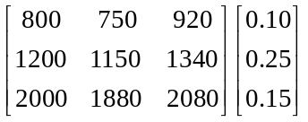

- 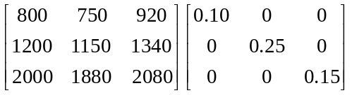

- 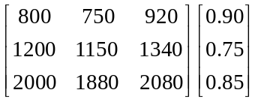

- 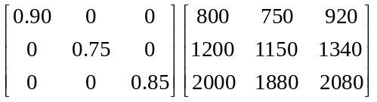

- 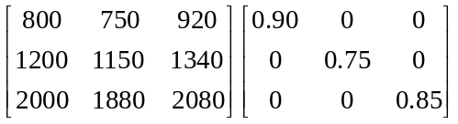

The following information should be used to answer Questions 6 and 7.

Residents of a large town have a choice of two power companies, Greenworld or Energyworld. In an effort to attract more customers both companies start a discounting campaign. The number of customers each company has in this town at the start of the campaign is shown in the table below.

Company | Number of customers
Greenworld | 2 430
Energyworld | 1 810

One of the energy companies predict that during the campaign, customers could change their energy company each month according to the transition diagram below.
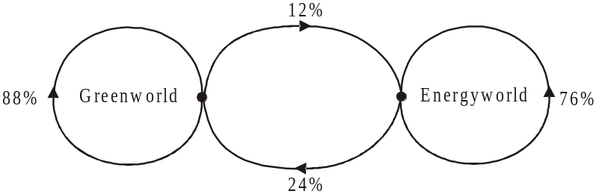

Question 6

The number of residents who are predicted to remain with the same energy company one month after the discount campaign begins is

- 1 376
- 2 138
- 3 440
- 3 477
- 3 514

Question 7

Six months after the discount campaign begins the number of customers that Energyworld has is closest to

- 1 441
- 1 456
- 1 667
- 2 784
- 2 799

Question 8

Matrix P is a 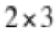 matrix. Four of its elements are zero and the other two are positive numbers.
Matrix Q is a square matrix and all its elements are positive, non-zero numbers. The maximum number of zero elements that the matrix product PQ can have is

- 0
- 1
- 2
- 3
- 6

Question 9

The families of students attending a large secondary school can elect to receive the weekly school newsletter in hard copy or email form. In week 1, equal numbers of hard copy and email versions of the newsletter were sent to families.
In subsequent weeks this changed according to the transition matrix

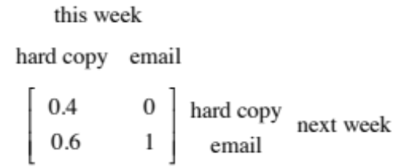

If this pattern were to continue it would be true to say that the number of email versions of the newsletter sent to families each week will

- decrease over the long term to 60% of the number sent in week 1
- increase over the long term to 140% of the number sent in week 1
- increase over the long term to 160% of the number sent in week 2
- halve over the long term
- double over the long term.

Further Mathematics Formulas

Core: Data analysis

standardised score: 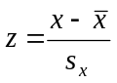
least squares line: 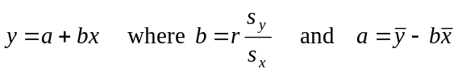
residual value: residual value = actual value – predicted value

seasonal index: seasonal index 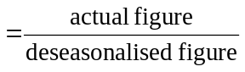

Module 1: Number patterns

arithmetic series: 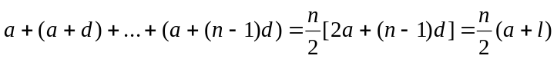
geometric series: 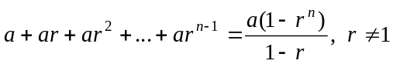
infinite geometric series: 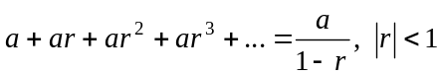

Module 2: Geometry and trigonometry

area of a triangle: 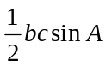
Heron's formula: 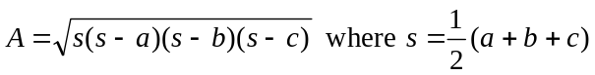
circumference of a circle: 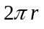

area of a circle: 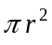

volume of a sphere: 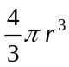
surface area of a sphere: 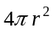

volume of a cone: 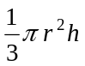
volume of a cylinder: 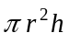

volume of a prism: 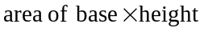
volume of a pyramid: 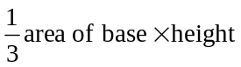

Reproduced with permission of the Victorian Curriculum and Assessment Authority, Victoria, Australia.
These formula sheets have been copied in 2012 from the VCAA website www.vcaa.vic.edu.au
The VCAA publish an exam issue supplement to the VCAA bulletin.
Pythagoras’ theorem 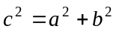

sine rule: 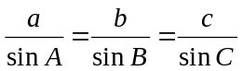
cosine rule: 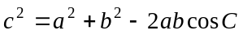

Module 3: Graphs and relations

Straight line graphs
gradient (slope): 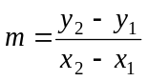
equation: 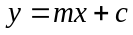

Module 4: Business-related mathematics

simple interest: 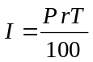
compound interest: 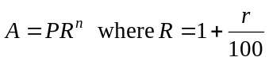
hire purchase: 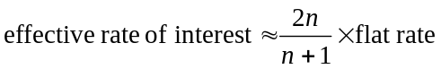

Module 5: Networks and decision mathematics

Euler’s formula: 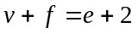

Module 6: Matrices

determinant of a 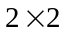 matrix 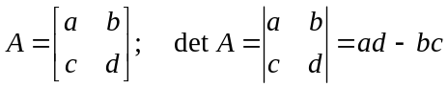
inverse of a matrix 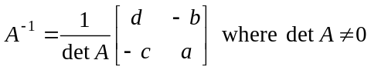

END OF FORMULA SHEET

Reproduced with permission of the Victorian Curriculum and Assessment Authority, Victoria, Australia.
These formula sheets have been copied in 2012 from the VCAA website www.vcaa.vic.edu.au
The VCAA publish an exam issue supplement to the VCAA bulletin.



